Problem Statement: You work for XYZ Corporation and based on the expansion requirements of your corporation you have been asked to create and set up a distinct Amazon VPC for the production and development team. You are expected to perform the following tasks for the respective VPCs.

Production Network: 1. Design and build a 4-tier architecture.

Let’s create our Production Network in Mumbai region.

Go to Vpc Dashboard 🡪 create VPC.

Fill the required details🡪

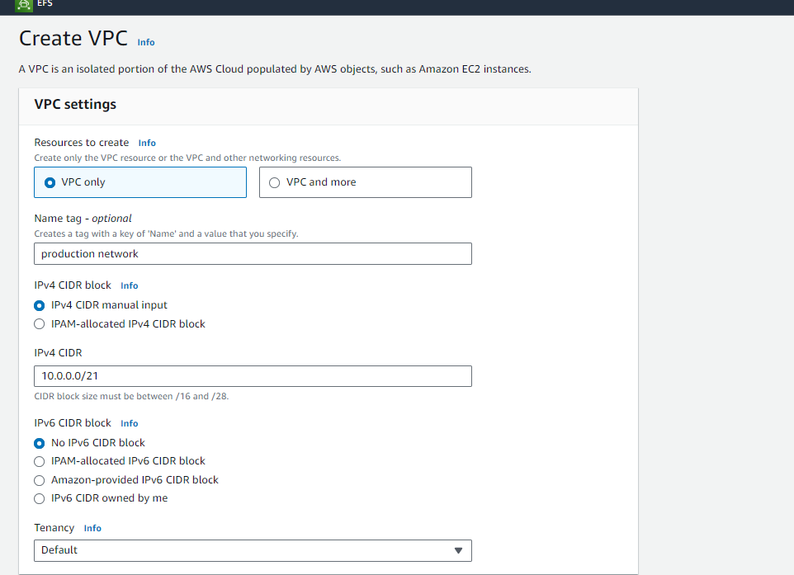

Create vpc.

2. Create 5 subnets out of which 4 should be private named app1, app2, dB cache and dB and one should be public, named web.

No go to VPC dashboard🡪selects subnet 🡪 create new

Fill the details u can use subnet calculator for CIDR range.

Like this fill the details for all 5. And create

To make web public add web entry in route table. For this create A Internet Gateway First For our VPC. And than create a public route table for our subnet with the route to internet-by-internet gateway. We don’t need route table for other now because they are by default private.

Now attach this route table to web.

3. Launch instances in all subnets and name them as per the subnet that they have been launched in.

Create instance in all subnets with the same name.

Click on Launch Instance 🡪Fill the details

Select other things default , don’t forget to assign public ip in web instance.

4. Allow dB cache instance and app1 subnet to send internet requests.

As we have to send internet request by db cache and app1 so we have to create a route table for them and make the changes like we do for web. lets create

Now as they are private to connect them over internet we need the NAT gateway.

So lets create a NAT gateway.

Here we have selected web where we are creating our NAT gateway . As it will work as a jump server.

Now in the route table which is attach to subnets make this entry of NAT gateway for the internet.

Do same for the app1 , db cache tabletable also

Now both of our private instance can connect to internet using NAT gateway.

Development Network: 1. Design and build 2-tier architecture with two subnets named web and db and launch instances in both subnets and name them as per the subnet names.

Lets create Development In Canada Region 🡪

We will follow same steps which we have done for the production VPC.

Lets create🡪

Launch instances in both the subnet.

2. Make sure only the web subnet can send internet requests.

So make sure web can send internet request we have to create internet gateway for our vpc attach it . create route table to route using IG over internet and attach it to web subnet.

3. Create peering connection between production network and development network.

Now to create peering connect between both of them go to Mumbai region vpc dashboard.

Click on peering connections🡪 create new. Fill the details

Here we have given vpc id of development network which is in Canada region.

When we create the peering connection we can see the pending request for this in Canada region.

Just accept .it

4. Setup connection between dB subnets of both production network and development network respectively.

As we have done the peering connection we can directly do ssh connection with db instance of both network as now they are in same range.

But to do this db should access over internet which it doesn’t have.

So we will use our we one as a jump server.

So connect web over internet.

Now create a pem file and copy paste the key using the file

Vi connect.pem

Now revoke access over pem using chmod

Chmod 400 connect.pem

Now connect to db instance of our same vpc.

Now create the pem file for the Canada region and revoke its access.

Now connect with the db instance of the region using that pem file.



